Height and Weight Restrictions
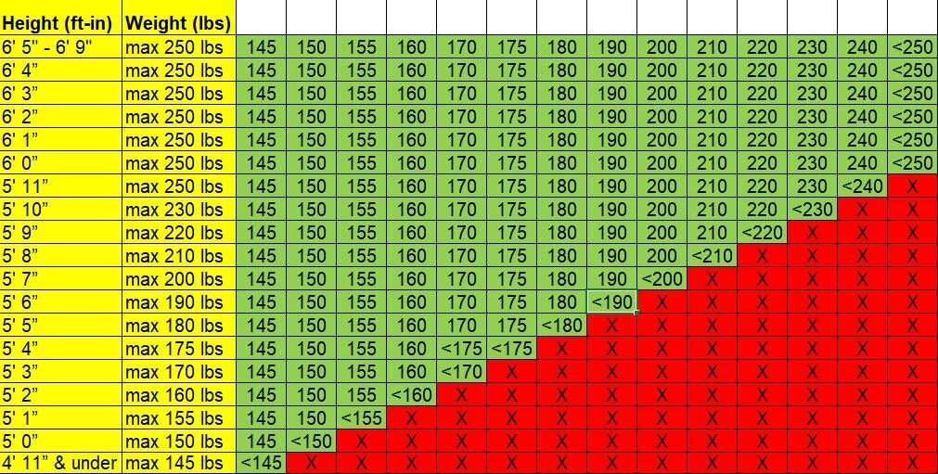
- We use the Height-to-Weight Proportion Chart shown below to ensure the safety and comfort of both the rider and our horses. It is a tool we use in determining if an individual can sit comfortably within the saddle parameters (seat size and stirrup length) and safely negotiate the terrain in which we ride, while staying balanced in the saddle. We realize the chart is a tool and not a perfect representation of a person’s individual ability, but as per our insurance it is a policy we must strictly adhere to as we strive to keep everyone safe.

- Accuracy of heights and weights given upon reservation (give or take 5 lbs) is very important,
- and sometimes essential to our ability to fulfill the reservation. We have horses of all sizes and strive to ensure our horses do not carry more weight than they can safely and comfortably carry, but we have limited horses that can carry riders over 200 lbs.
- If there appears to be a discrepancy of what was listed on your reservation we do reserve the right to check your weight at check in and refuse services without a refund if you fall outside of the height-to-weight restrictions.
- Please do not make us get out the scale, it’s awkward for everyone so we appreciate your accuracy.
- All riders must be able to mount and dismount their horse using a mounting block without assistance. We implement this as a safety precaution in the event of an issue arising with a rider or horse during the ride that would require a rider to dismount on the trail.
- WE APPRECIATE YOUR UNDERSTANDING AND HONESTY AND
- OUR HORSES THANK YOU!

